**Institute of Information Technology (IIT)**

Jahangirnagar University



**Lab Report: 05**

**Course Code: ICT-4104**

Submitted by:

Name: Md. Shakil Hossain

Roll No: 2023

Lab Date: 10.08.2023

Submission Date: 16.08. 202

**EXPERIMENT NO:**  05

**NAME OF EXPERIMENT**

Determination of power spectrum of a given signal.

**AIM**

Determination of Power Spectrum of a given signal.

**APPARATUS**

Software: MATLAB

**THEORY**

The power spectrum describes the distribution of signal power over a frequency spectrum. The most common way of generating a power spectrum is by using a discrete Fourier transform, but other techniques such as the maximum entropy method can also be used. The power spectrum can also be defined as the Fourier transform of autocorrelation Function.

**METHODOLOGY**

**Algorithm:**

Step I: Give input sequence x

Step II: Give sampling frequency, input frequency and length of the spectrum.

Step III: Find power spectrum of input sequence using matlab command spectrum.

Step IV: Plot power spectrum using specplot.

**Flow Chart:**

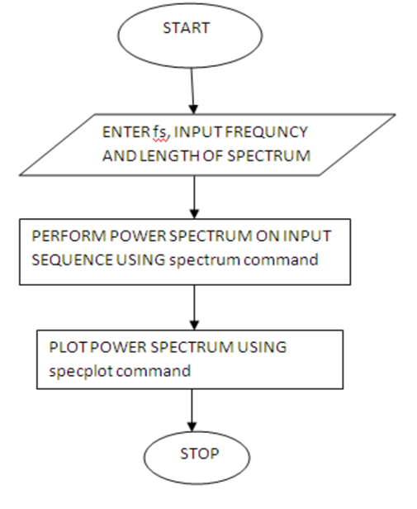

**Program:**

clc;

clear;

close all;

N = 1024;

fs = 8000;

f = input('Enter the frequency [1 to 5000]: ');

n = 0:N-1;

x = sin(2 * pi * (f / fs) * n);

[Pxx, frequencies] = periodogram(x, [], N, fs);

figure;

plot(frequencies, 10 * log10(Pxx));

grid on;

xlabel('Frequency (Hz)');

ylabel('Magnitude (dB)');

title('Power Spectrum of x(n)');

**Input:**

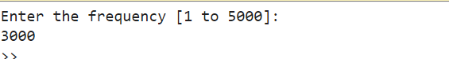

**Output:**

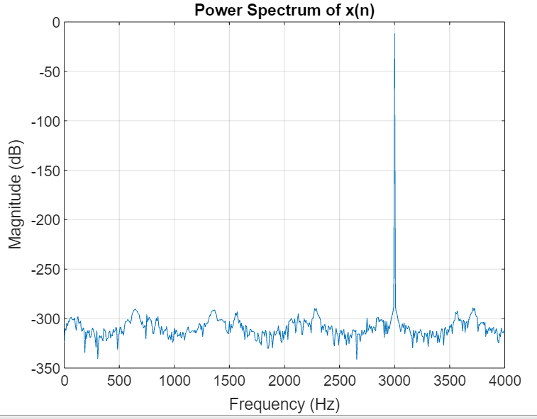

**Exercise 1:** Find power spectrum of the signal x(n)=cos(2*pi*50*n).

**Program:**

clc;

clear;

close all;

N = 1024;

fs = 8000;

f = input('Enter the frequency [1 to 5000]: ');

n = 0:N-1;

x = cos(2 * pi *50* (f / fs) * n);

[Pxx, frequencies] = periodogram(x, [], N, fs);

figure;

plot(frequencies, 10 * log10(Pxx));

grid on;

xlabel('Frequency (Hz)');

ylabel('Magnitude (dB)');

title('Power Spectrum of x(n)');

**Intput:**



**Output:**

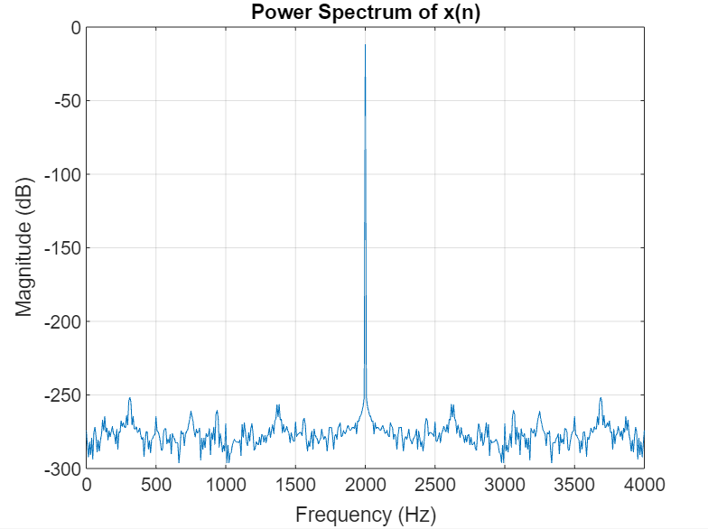

**DISCUSSION**

This experiment demonstrates a simple yet essential process for determining the power spectrum of a given signal. By allowing user input for the signal frequency, the code enables the exploration of different frequency components in the power spectrum. The visualization of the power spectrum aids in understanding the signal's frequency content and helps identify dominant frequency components.

**CONCLUSION**

Analyzing the power spectrum of a signal provides crucial insights into its frequency components and distribution. This technique aids in understanding signal characteristics, noise sources, and potential applications in various fields. By deciphering frequency-domain information, researchers and engineers can make informed decisions for signal processing, communication systems, and more.

**VIVA QUESTIONS**

**1. Define power signal.**

A power signal refers to a signal whose samples have a non-zero average power over an infinite number of samples. Mathematically, for a discrete signal $x\left[n\right]$ the power is calculated as:

$P^{}=$ $\lim_{N→∞}\frac{1}{N}\sum_{n=-∞}^{∞}{}{\left|x\left[n\right]\right|}^{2}$

Where:

* $P^{}$ is the power of the signal.
* $N$ is the number of samples considered for power calculation.
* $x\left[n\right]$ is the signal in the discrete domain.

**2. Define energy signal.**

An energy signal in the discrete domain refers to a signal whose samples have finite energy over a specific, often finite, number of samples. The mathematical definition for a discrete energy signal $x\left[n\right]$ is:

$E=$ $\sum_{n=-∞}^{∞}{}{\left|x\left[n\right]\right|}^{2}$

Where:

* $E^{}$ is the energy of the signal.
* $x\left[n\right]$ is the signal in the discrete domain.

**3. Define power spectral density of a signal.**

The power spectral density (PSD) of a signal is a fundamental concept in signal processing that describes how the power of a signal is distributed across different frequency components. For a discrete-time signal $x\left[n\right]$, the power spectral density $S\left(f\right)$ can be estimated using the discrete Fourier transform (DFT) of the autocorrelation sequence $r\left[k\right]$ of the signal:

$S\left(f\right) =$ $\sum_{k=-∞}^{∞}{}r\left[k\right] e^{-j2πfk}$

Where:

* $S\left(f\right)$ is the power spectral density of the signal.
* $r\left[k\right]$ is the autocorrelation sequence of the signal.

**4. How the energy of a signal can be calculated?**

The energy of a signal can be calculated by summing the squared magnitudes of its samples over a specified interval. For a discrete-time signal $x\left[n\right]$ defined over a finite number of samples $N$, the energy $E$ is calculated as the sum of the squared magnitudes of the samples:

$E=$ $\sum_{n=-∞}^{∞}{}{\left|x\left[n\right]\right|}^{2}$

However, since most signals have finite support (a finite number of non-zero samples), the summation is limited to the range where the signal is non-zero:

$E=$ $\sum_{n}{}{\left|x\left[n\right]\right|}^{2}$

Where:

* $E^{}$ is the energy of the signal.
* $x\left[n\right]$ is the signal in the discrete domain.

**5. Explain difference between energy spectral density and power spectral density.**

**Energy Spectral Density (ESD):** Describes how the energy of a signal is distributed across frequencies. Used for finite-energy signals.

**Power Spectral Density (PSD):** Describes how the power of a signal is distributed across frequencies. Used for signals with constant power over time.

This is the key difference between energy spectral density and power spectral density.

**6. Explain the PSD plot.**

The Power Spectral Density (PSD) plot is a graphical representation that illustrates how the power of a signal is distributed across different frequencies. It provides valuable insights into the frequency composition and power intensity of a signal. Here's an explanation of the key aspects of a PSD plot:

* Frequency Axis: Horizontal axis showing frequency range.
* Power Axis: Vertical axis indicating power intensity (dB/W).
* Peaks: Elevated points represent dominant frequency components.
* Valleys: Low points correspond to less powerful frequencies.
* Peak Heights: Reflect power strength of specific frequencies.
* Peak Widths: Indicate frequency component bandwidth.
* Flat Regions: Consistent power across certain frequency ranges.
* Analysis: Crucial for identifying signal characteristics, harmonics, noise in fields like telecom, audio, vibration analysis.

**7. What is the importance of PSD?**

The Power Spectral Density (PSD) is crucial because it:

* Reveals signal frequency components, aiding analysis.
* Guides communication system design, optimizing performance.
* Assesses audio quality, aiding equipment and noise reduction.
* Identifies vibration patterns in mechanical systems.
* Informs spectrum management, avoiding interference.
* Guides signal processing techniques like filtering and equalization.
* Facilitates fault diagnosis through vibration analysis. In sum, PSD enhances signal understanding, system efficiency, and decision-making in various fields.

**8. What are the applications of PSD?**

Here are the applications of Power Spectral Density (PSD):

* Communication Systems: Optimize wireless channels and analyze interference.
* Audio Processing: Design audio equipment, cancel noise, and assess quality.
* Vibration Analysis: Identify mechanical vibrations and faults.
* Spectrum Management: Efficiently allocate frequencies to avoid interference.
* Signal Processing: Guide filtering, compression, and modulation.
* Fault Detection: Diagnose machinery issues through vibration.

PSD's applications span diverse fields, enhancing signal analysis and system optimization.

**9. Explain MATLAB function randn(size(n)).**

The MATLAB function randn(size(n)) generates an array of random numbers sampled from a standard normal distribution (Gaussian distribution) with a mean of 0 and a standard deviation of 1. Here's an explanation of the function and its components:

* randn: This is a built-in MATLAB function that generates random numbers from a normal distribution.
* size(n): This part determines the size of the output array. The size() function returns the dimensions of the input variable n. If n is a scalar, it determines the size of the array directly. If n is an array or a matrix, size(n) returns the dimensions of that array or matrix.

So, when you use randn(size(n)), MATLAB generates an array of random numbers that has the same dimensions as the array or matrix n, with each element drawn from the standard normal distribution.

For example:

* If n is a scalar, randn(size(n)) generates a single random number.
* If n is a vector, randn(size(n)) generates a vector of random numbers.
* If n is a matrix, randn(size(n)) generates a matrix of random numbers with the same dimensions as n.

**10. What is the need to represent the signal in frequency domain?**

Representing a signal in the frequency domain is essential because it offers valuable insights that are not as apparent in the time domain. Here's why representing signals in the frequency domain is crucial:

* Frequency Components: Frequency domain reveals signal's underlying frequency components, aiding analysis.
* Dominant Frequencies: Identifies dominant and harmonic frequencies in complex signals.
* Filter Design: Facilitates designing filters and equalizers to enhance signal quality.
* Spectrum Analysis: Detects bandwidth, interference, and modulation in communication systems.
* Signal Compression: Allows selective data compression based on frequency importance.
* Mechanical Vibrations: Uncovers resonance frequencies and vibrations in mechanical systems.
* Fault Detection: Detects anomalies and irregularities by analyzing frequency changes.
* Fourier Analysis: Simplifies complex signal analysis using transform techniques.
* Signal Manipulation: Enables operations like multiplication, convolution, simplifying complex calculations.
* System Optimization: Essential for optimal design in audio, communications, and control systems.

In essence, the frequency domain provides insights into a signal's composition, behavior, and interactions that are not easily apparent in the time domain. This knowledge is vital for various engineering, scientific, and practical applications.

**REFERENCE**

[1] Wikipedia Contributors, “Spectral density,” *Wikipedia*, Aug. 01, 2023. Available: https://en.wikipedia.org/wiki/Spectral_density?fbclid=IwAR1iMVx_kvvjG4CHA7BADjM44SvFiZx0nX2ncUB5W-QqHXPbP3p1edGXWfU. [Accessed: Aug. 15, 2023]